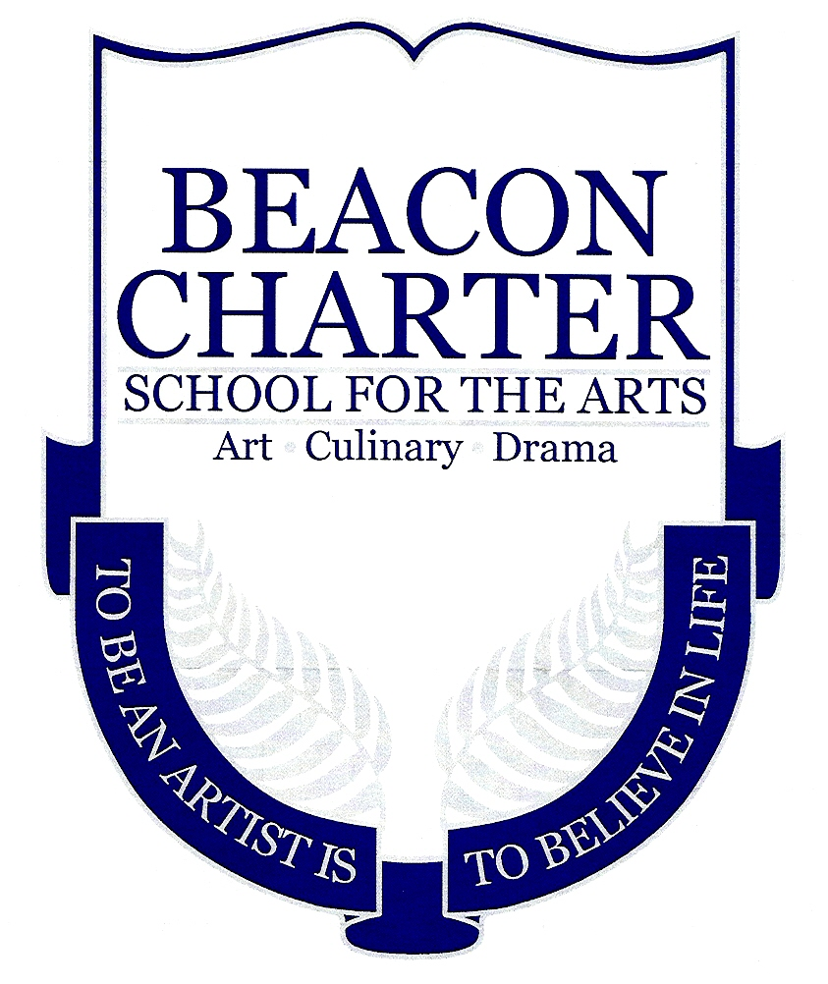  Grade Level: 12  Assignment Criteria –  ALL ARTS- 5 paragraph essay | Mrs. Patricia Hawkridge, MFA  Email: phawkridge@beaconart.org
Project: SENIOR ARTS NIGHT Reflection | Assigned Date: Monday -11/25/13  2/14/13 | Due Date: Friday -12/6/13
Objective: To engage in meaningful self-assessment about the individual student’s work during their SENIOR ARTS NIGHT

Paragraph One: CHOSE ONE OF THE FOLLOWING:
The culinary dish(es) I chose to prepare was……
My scene(s) was about……
My artwork focused on…..

Paragraph Two: CHOSE ONE OF THE FOLLOWING:
The highlight of presenting my culinary creations was…..
The highlight of my performance was…..
The highlight of exhibiting my artwork was…..

Paragraph Three: The biggest challenge of my senior arts night was……

Paragraph Four: I was happy/unhappy with the viewer’s response to my work during my
Senior arts night because…..

Paragraph Five: I want to improve…………..so, next time I’m going to……….

I mark my work during my Senior arts night a _____/10 (with ten
being the highest)

The reason I give myself this mark is…..

