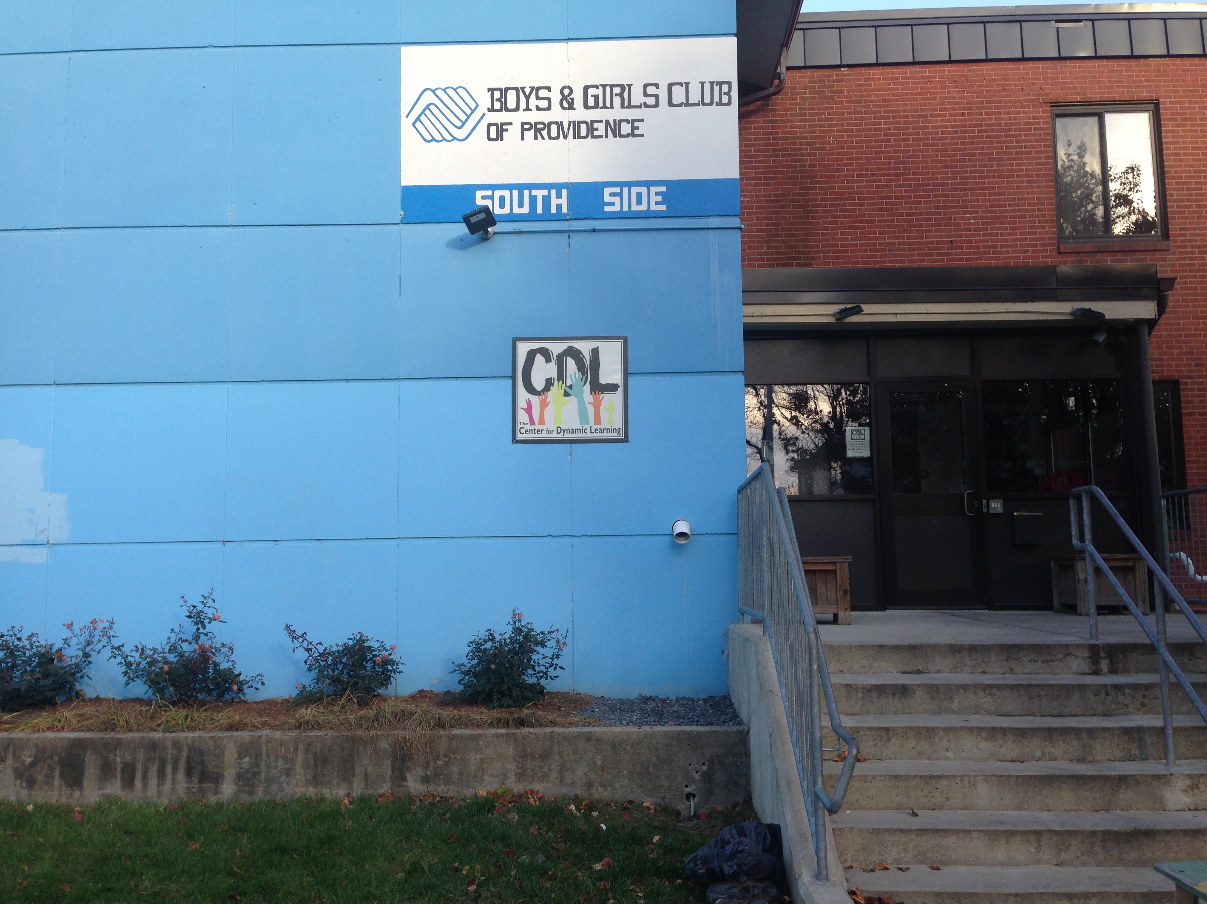
Jason Robert LeClair
Descriptive Case Study of the Center for Dynamic Learning
November 23, 2014

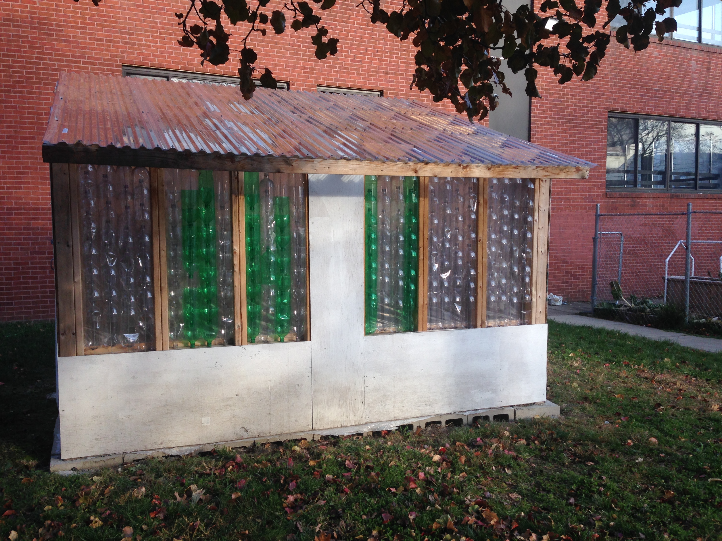
In one of the poorest and in need sections of Providence, Rhode Island, there is this glimmer of hope on a back street. It is the Center for Dynamic Learning. Situated in the basement of the Boys and Girls Club at 1 Louisa Street, the bright colored sign sporting the CDL logo with six hands reaching up. It is a welcome bit of warmth to these worn backstreet homes in the rundown neighborhood known as South Providence. I knew I was in for something great inside this facility as I walked past the greenhouse made from recycled soda bottles and past the solar powered geothermal garden. Entering through a rear door, I walked downstairs to a rich and vibrant set of labs where creative thought meets scientific outcomes, in a place where learning is truly dynamic. Just as dynamic as the people who run this inventive haven for students in the urban communities of Rhode Island. Mixed in with the biology equipment, laser cutters, 3D CAD lab, and full workshop is a black box theatre and scene shop/art studio. It is a creative/inventive play land.
My study is founded on a curiosity around the STEM to STEAM movement. When I first heard of this educational revolution, I was intrigued to say the least. I am a multi-disciplined artist who works with the STEM (Science, Technology, Engineering, and Math) elements on a daily basis in my artistic life. As a scenic designer, I employ many of these elements in creative and multi-dimensional ways, so the STEAM (STEM with the addition of Art) movement certainly spoke to me. John Maeda, the former President of the Rhode Island School of Design had originated the concept of STEAM while serving at RISD. The design and art aspect potential of a STEAM program are goals to which Maeda strived and pushed to be recognized federally. In the foreword to The Art of Critical Making, Maeda states, “STEAM advocates for the federal government to integrate art and design with its growing emphasis on STEM education and research.” Maeda continues with, “By doing so, we will develop the creativity needed to drive our innovation economy forward and keep America competitive throughout this century” (Maeda, 2013. pg. 6). During the course of my interviews with Beth Cunha, MFA, Co-founder and Executive Director of CDL, she spoke of the fact that Maeda’s concept for STEAM was too narrow. She believes that it goes beyond art and design. All forms of art, “its about the critical and creative problem solving process” (Cunha, B. personal communication, November 18, 2014). Cunha includes the performing arts in this. That, in particular, is of interest to me.
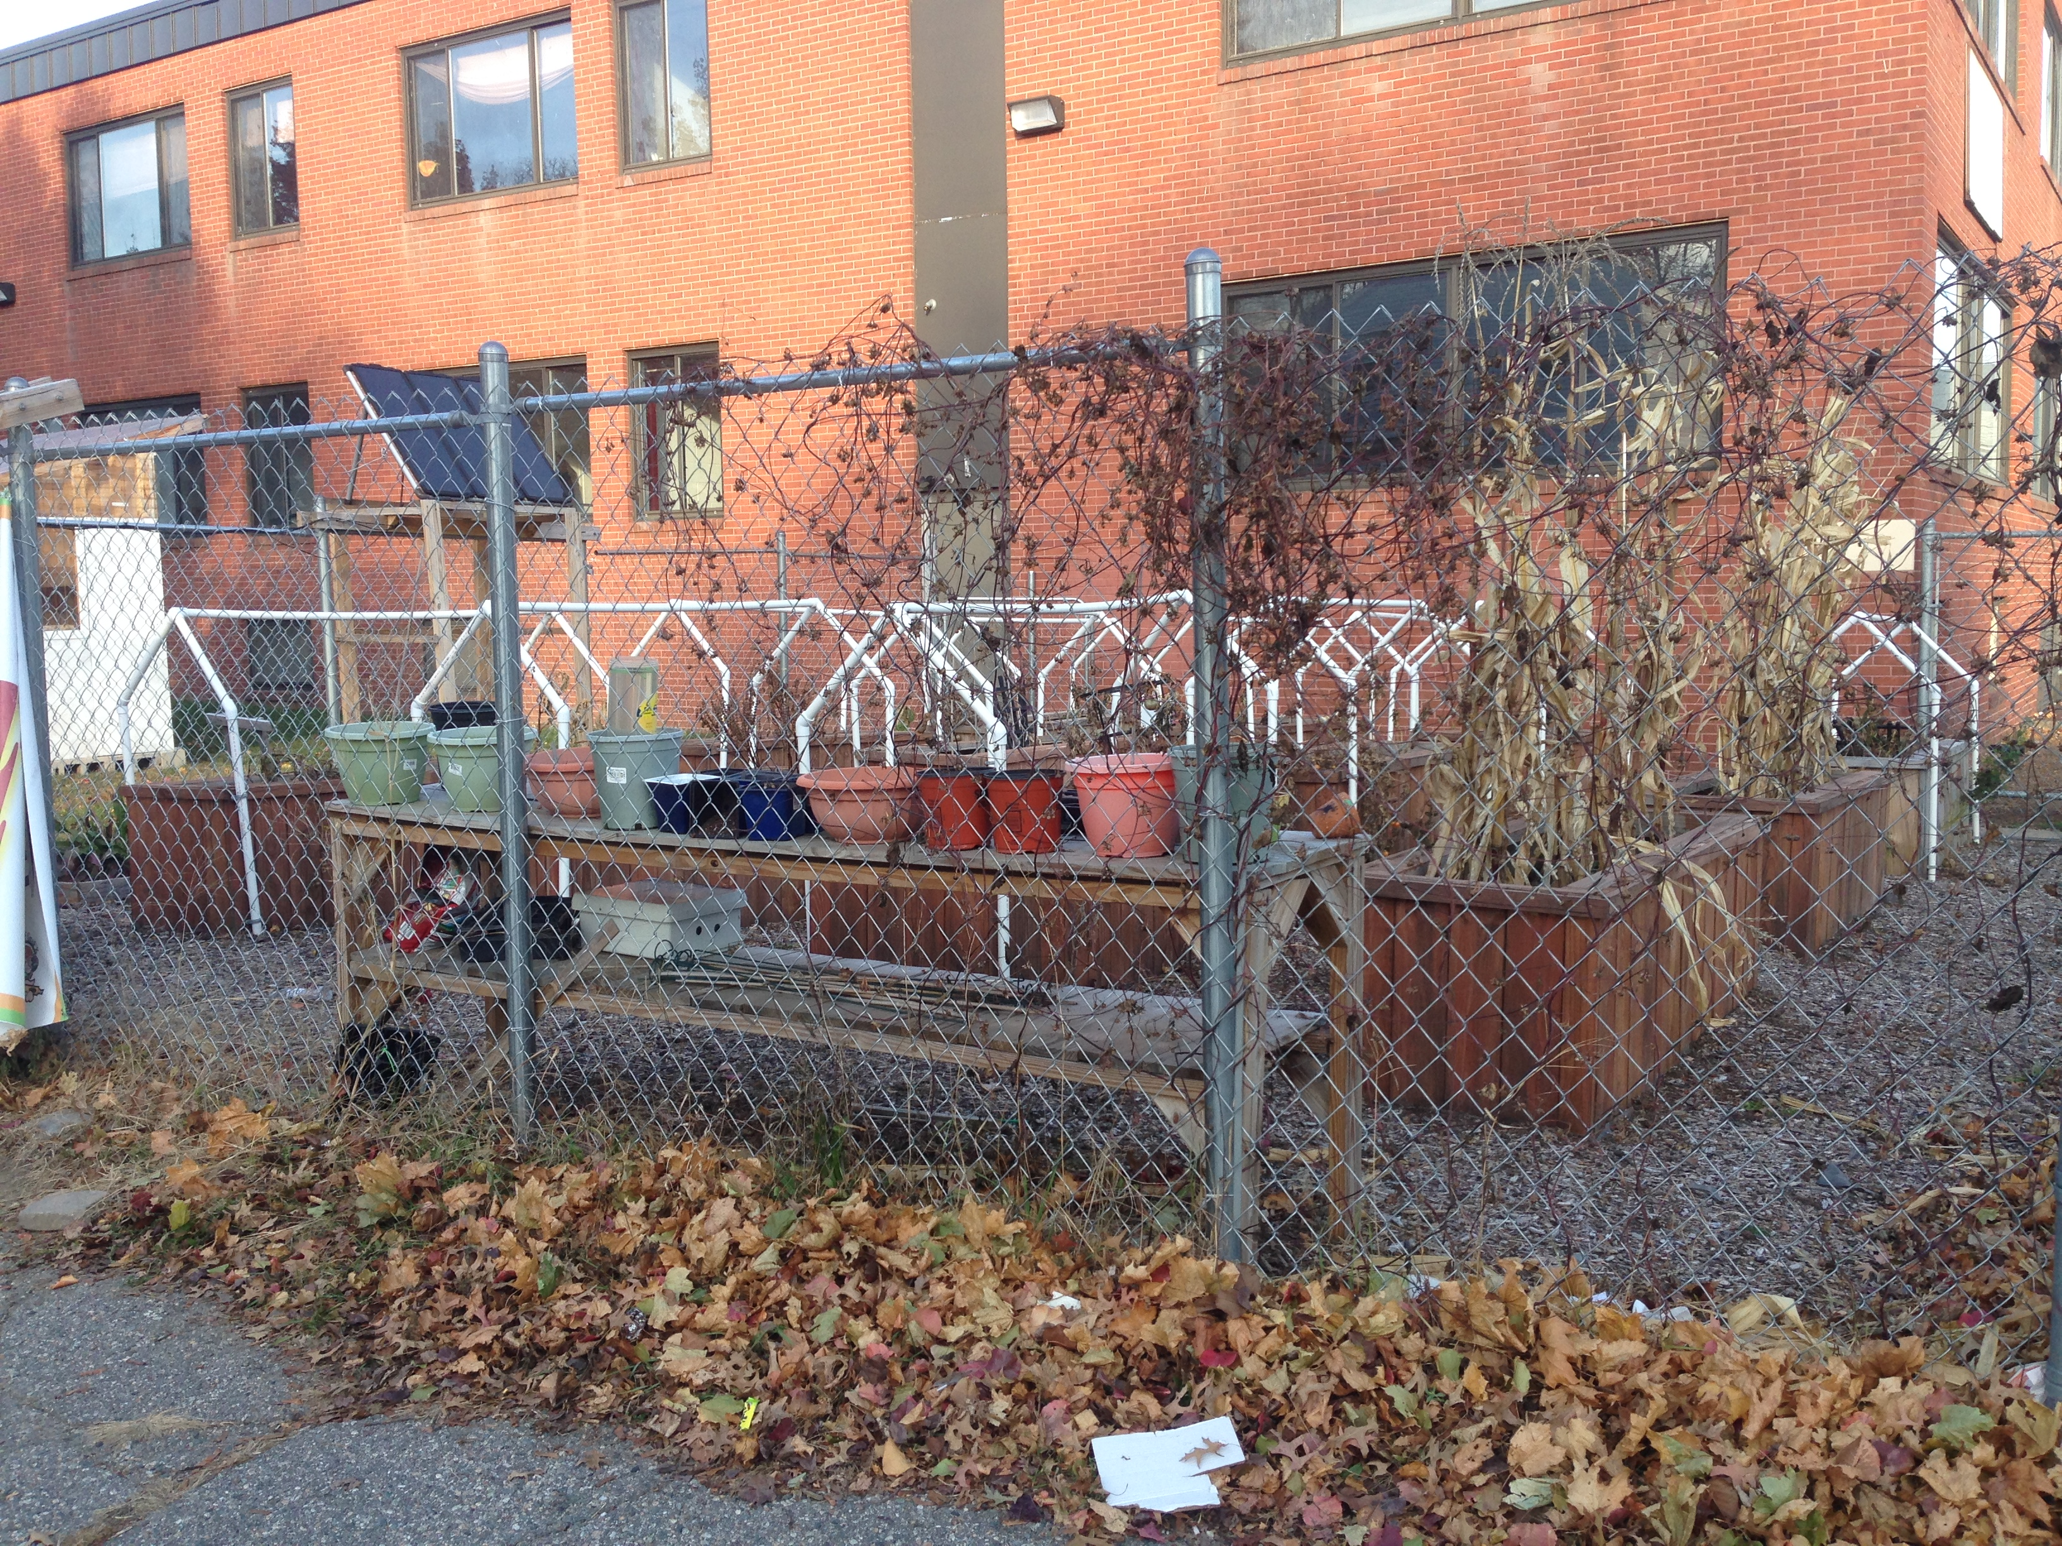
I teach visual art, theatre arts, art history, and different electives throughout the years at the Beacon Charter High School for the Arts in another urban location in Rhode Island, Woonsocket. I have considered myself a Renaissance man of sorts. The Cunhas certainly deserve the title of Renaissance people. Beth Cunha is a performing artist with a heavy background in science. Her first loves in school were the sciences. She related a story to me during our talk about what drove her to co-found this program. As a freshman in high school she was the consistent winner of the school science fair. At the urging of a friend, Beth auditioned for the school play. When the cast list came out she asked the director if she had done well. To wit, the director replied, “You won the science fair, correct? I’d stick to science” (Cunha, B. personal communication, November 18, 2014). Eve with that, she did not lose her love of the stage. Two things helped create CDL. The first was a growth from Cunha’s original model of after school enrichment programs called The Travelling Theatre Company. Along with her foundation of theatre as an educational force for social change, her husband, Kevin joined her after an over twenty-two-year career in consumer products manufacturing and engineering. According to his bio on the CDL website, Kevin holds multiple degrees and certifications in advanced sciences and engineering. He uses his love of biology, technology, industrial design and engineering to expand the inventive possibilities of his students. Employing green technologies, he has used the engineering and biology experience to create a hydroponic/aquaponics lab, which generates plants that are placed in the urban garden located just outside CDL’s back entry. This past summer, they harvested over 3000 tomatoes from the garden in addition to many other crops such as corn. These two powerhouse individuals lead an astonishing group of students, teachers and support staff to new heights with the goal of breaking the cycle of poverty and classism.
The second driving force for the founding of this program was the need to bring STEAM to communities in need of more than just arts enrichment. Communities such as Central Falls, a school district in the most densely populated one square mile of Rhode Island. The vast majority of students are from immigrant families and also below the poverty line. Not long ago, the Superintendent of schools for Central Falls, Dr. Fran Galo, fired all of the teachers in the district. Against union intervention, she brought in CDL for theatre enrichment programs and soon to follow, engineering and technology programs. Kevin and Beth happily took on the challenge.
The award winning team at CDL has decided to push the limits of where the student can go. The mission statement for the organization sounds like an modified form of the apprenticeship model of learning, “The Center for Dynamic Learning nurtures life and career skills in youth by empowering our students to explore their limitless potential through creative, engaging and innovative theater arts and science programs” (Our Mission. n.d. para. 1). Apprenticeship is a model of learning that has been modified and reworked and is on the rise in the form of practical education. This methodology of instruction, particular to trades, has been adapted to fit in other situations including the arts. (Charland, 2005). With their dynamic learning model, the Cunhas are taking on apprenticeship at a different degree. Kevin, the master, is allowing his apprentices not only freedom of invention, but demands creative problem solving to attain the skills. His claim is that he is not out to create engineers as much as tap into the creativity and inherent artistry of each student (Cunha, K. personal communication, November 18, 2014).
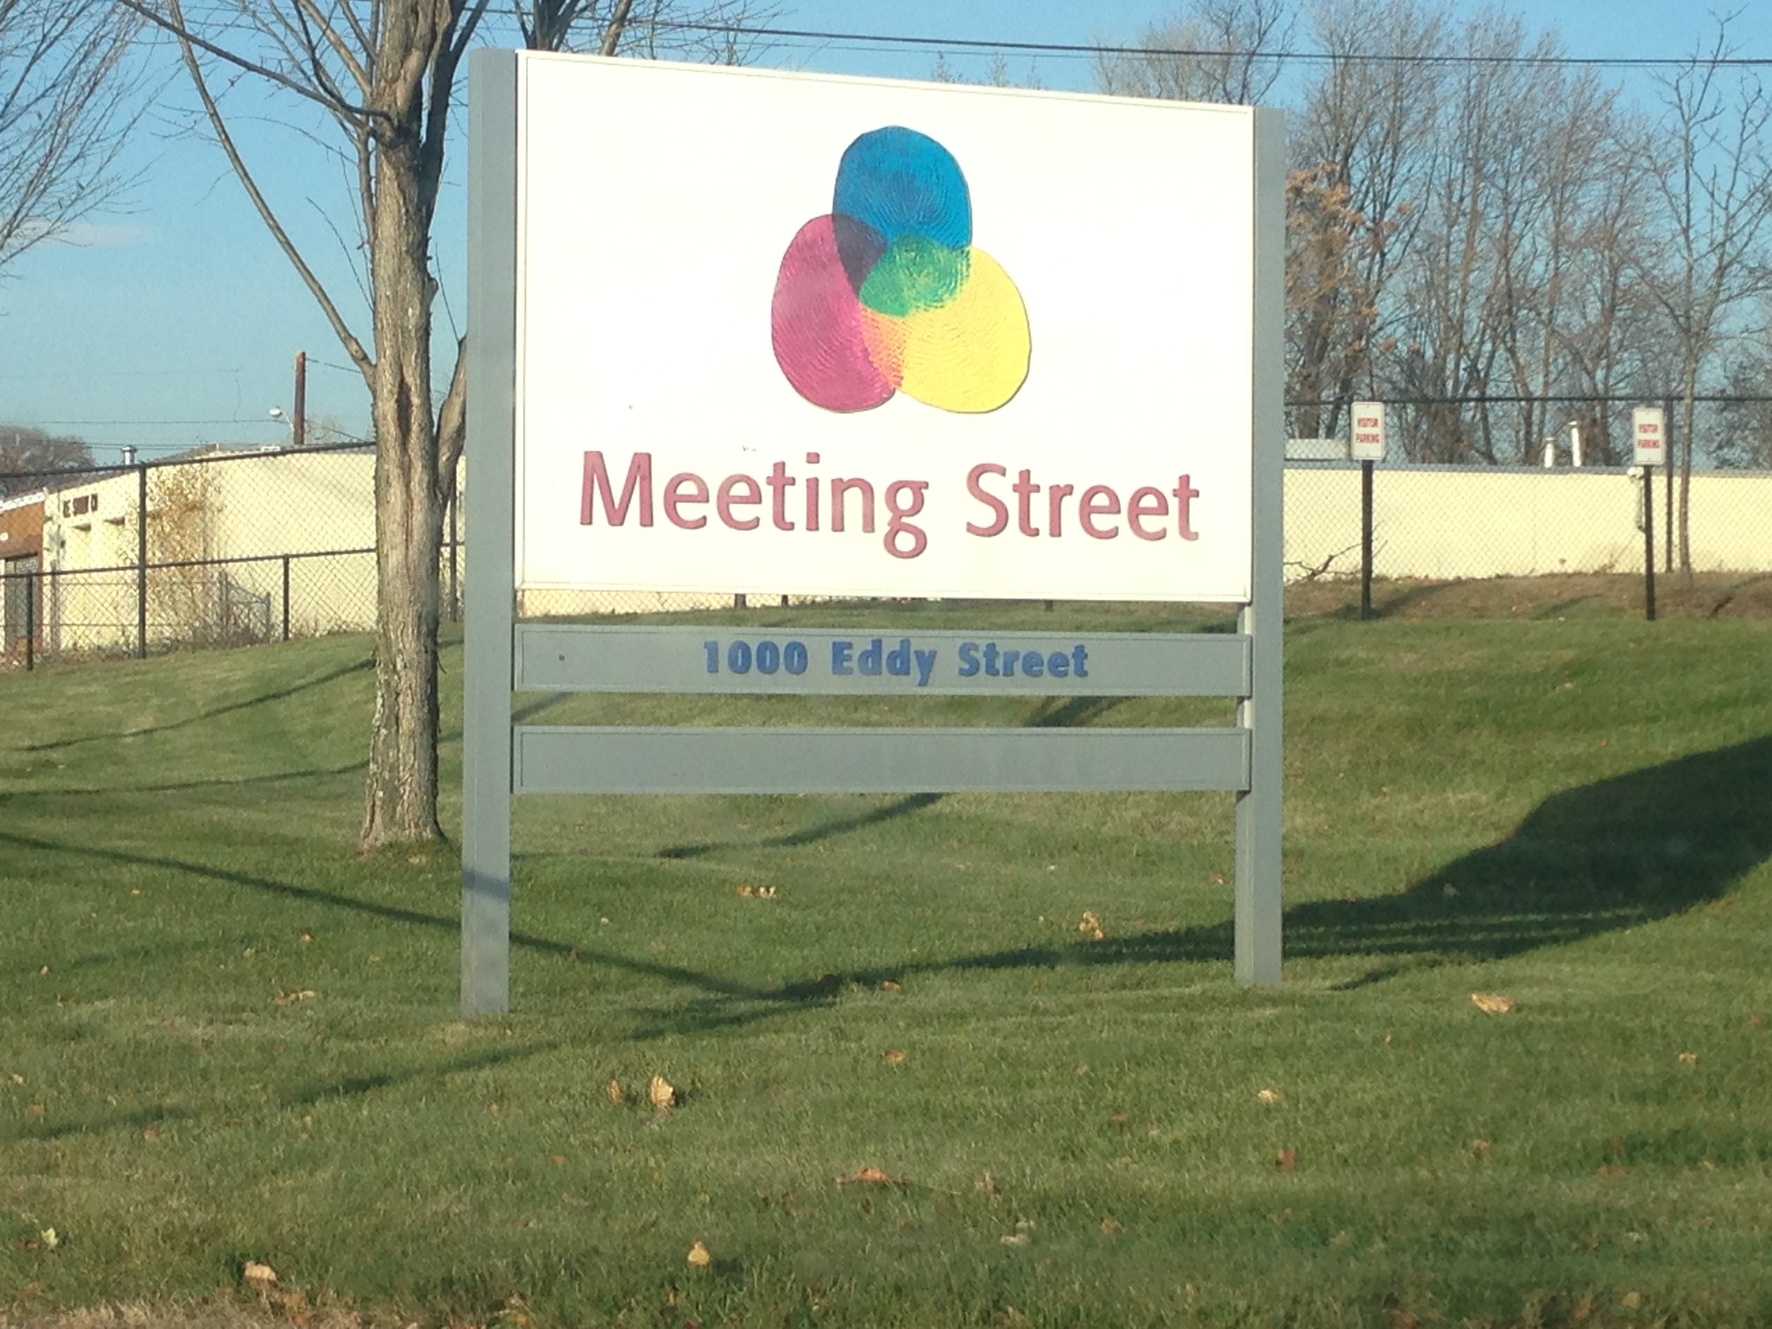
So this is where CDL best shines. Introducing his students to the concepts, science, and design is one thing, but to have them actually produce the items proposed is quite another. Still more impressive is the community involvement that inspires the manufacturing component of CDL’s program. The team has taken on a client for their design and manufacturing students, the Meeting Street School. The Meeting Street School is focused on providing the highest quality education to students of all abilities. The school’s focus is on caring attention being given to each and every child regardless of ability (About Meeting Street. n.d., para. 1.). In order to provide this, there are many adaptive needs required by the myriad of occupational therapists, special educators, nursing staff, etc. Perhaps one of the most amazing responses to this has been the curriculum of CDL’s SLIDE programming in which their STEAMM curriculum fits. SLIDE (Science Learning Industrial Design Engineering) is a multi-tiered program for all school age students. The pivotal section of the program that applies to involvement with Meeting Street School is CDL’s high school programming. The courses are Introduction to Mechanical Fabrication, Creative Design Engineering, and Manufacturing for Change 1 & 2. Within these four courses, students are taught and able to manifest ideas to aid the students and staff at Meeting Street. An example of this is answering the problem of iPads running out of charge for the staff as each staff member has to keep detailed digital notes throughout the day. The CDL team of students devised chargers for the iPads that were run by the wheelchairs of the Meeting Street Students. Every time the student moved, the magnetic chargers would charge the iPad (Cunha, B. personal communication, November 18, 2014).
The biggest difference between CDL’s ability to do this and other design programs comes in their second “M” in STEAMM; Manufacturing. Beth had said during our interview regarding STEAM, “manufacturing was lumped in there… you can’t have it as an accidental byproduct of an exercise” (Cunha, B. personal communication, November 18, 2014). So the fabrication and realization of these inventions happens in real time by the hand of the designers. “By making purposeful connections in and through STEM and the Arts, all skills, processes, and subjects are strengthened and the students gain a richer learning experience” (Riley, 2012. pg. 9). This engagement of the students at CDL causes not only the awareness of the integration of arts and STEM, but also puts levels of reality to the concepts. First, it places directly in the hands of the students the problem solving required by any inventive, creative thinker while also giving them the tools with which to solve the problems. But how do these hundreds of thousands of dollars worth of tools and advanced equipment get to an alternative arts program? Beth and Kevin are constantly writing grants with the help of the other nine members of their Board of Directors. Having received many of these grants as well as awards for innovation in education and community change, they have managed to carve out more and more funding in order to expand the program. For example, Kevin was late for our appointment during my visit because he had found a new partner in investing. This person would be yet another of the several spokes used to drive the CDL wheel.
As Kevin left for the Central Falls’ middle school biology program he was to be conducting, Weird Science, I was left with Jeffery Rosenzweig the program manager for SLIDE. Earlier that day, Kevin and I had stopped into the black box theatre where the small group of high school students in the Creative Design Engineering class were receiving sensitivity training from Jeffery. This is not required by the Meeting Street School, but rather CDL elects to have its staff trained to become trainers passing the knowledge to the students before they enter Meeting Street for their field research. I observed Jeffery’s handling of the students, seeming almost like a shop foreman. Not a bad thing, just a very controlled and business-like demeanor with the students. This worked as each student paid strict attention to everything Jeffrey had to say. There was an air of respect from both student and mentor in this situation. Later in the afternoon, after interviewing Kevin and having the full tour of the facility, I was, as I said, left with Jeffery in the Young Inventors class.
On the website, this course is advertised to allow students to, “Follow in the footsteps of some of the greatest minds in history. DaVinci, Newton, and Einstein have nothing on you! Join us as we experiment and build systems and simple machines that can send small items (or maybe even a classmate!) FLYING” (Young Inventors, n.d., para. 7. right column). I found out how true this was when the ten students poured into the lab talking about the catapults from last week. The faces were shining and rearing to go. This class was a middle school level of the program. As the class assembled, what I expected to happen, happened, mild chaos. Whether it was an unexpected adult in the room (myself) or the excitement to see what would follow up something so cool as inventing your own working catapult, these children were as enthused about learning in this environment as if they were in a toy shop. The eyes were wide and the energy was nearly uncontrollable. To begin the day, Jeffrey, along with his student assistant, Justin (one of the students from the advanced Creative Design Engineering course), settled the young students and performed a basic assessment to see if the students were in the proper mindset to handle the tools. They played an icebreaking game then proceeded with a points oriented naming game of the tools in the shop. Most of these tools were items I recognized only due to the fact that my father was an industrial arts teacher for thirty-five years and I have been building sets for over twenty years. These children, however knew the functionality of these devices just as well as the names. I was duly impressed, but I was about to be thrown a greater impression.
The class began, students broke out projects they had been working on either in teams or individually. Safely goggles poised on her forehead, the smallest child, a sixth grade girl, perky and unassuming called out, “Justin!” as she stood by the massive industrial radial arm saw. Her block of wood in hand, she waited for the supervisor to arrive, then slowly and methodically on her own, turned on the machine and cut through the block like a precision carpenter. She was barely tall enough to grasp the trigger handle! This continued throughout the shop. Students did not grow impatient waiting for supervision, they simply waited their turn. The building and creating, measuring with calipers whether a drill bit would be the proper size to pilot a hole for a certain screw, deciphering how a set of framing clamps could help one create a box, etc. All of this had the shop abuzz. Teaching moments abounded for Jeffery as he ping ponged cool, calm, and collected between the students’ individual tasks. Each child had something to do, and if they weren’t working on a project in particular, they went and found pieces from the scraps and tried imagining what they could make with the items that were someone else’s waste. Running a shop at my own school (with about a tenth of the equipment and most of it mine), I was speechless at the organized chaos before me. It was like mixing a very well run creative process art studio with a woodshop.
The only suggestion I may offer to CDL is one of which they are fully aware. The staffing is too small. It was very difficult for me to not throw on a set of goggles myself and lend a hand. I asked students questions and got a gist of the overall feeling from the kids. It was a typical cross section of interest and motivations. With more staffing, more of the students may have been able to be fully engaged rather than waiting for turns to get things done. In reviewing the mission of CDL, “(CDL) nurtures life and career skills in youth by empowering our students to explore their limitless potential through creative, engaging and innovative theater arts and science programs” (Our Mission., n.d. para. 1) I am starting to think that there is a need to expand the statement. Design is at such a high caliber within the program I think it needs to be mentioned in the mission. Kevin was relating to me that he had a student who graduated from the program last year who has invented a device for the medical community. This device is a simple pill holder that carries a single dose of heart attack stopping aspirin. It is worn as a piece of jewelry, i.e. tie pin. It was such a successful design, the student already has backing from companies to create the prototype of this potentially life saving device (Cunha, K. personal communication, November 18, 2014).
With all of this wonderful work being done in the field of industrial design education, I asked Kevin some pointed questions concerning art education.
Jason – How are the visual arts made equal in to the STEMM portions of the program?
Kevin – I’m an engineer that believes that art has to be involved in everything that we create, because if I design a car and its’ ugly no body’s going to buy it. It has to look cool… I try to push the A in Art for STEAM is important to me.
Jason - This is my worry about STEAM is that once it gets integrated into schools, “Oh well we’ve got art inside this, why do we need an Art program?” How do you feel about that?
Kevin - Well, its funny that you say that. I’ve, there’s, You have to remember, I’m the one that builds the sets and stuff too for us.
Jason - And I know that. That’s why I’m asking you, because you work both sides.
Kevin - To me that would be the worst decision anyone could make because it’s not art, art is not art, art is everything. Like there are so many different forms of art, like you can’t consider glass blowing to metal sculpture. People say “Oh, it's the same thing, your making a creation out of it,” yeah, but its two different types of sciences… That would be the worst thing anybody could do. That’s a closed mind person. (Cunha, K. personal communication, November 18, 2014)
This last question may seem to be a fringe question, but in the wider art education community it is a worry. Several people asked the same, or similar question to an expert panel at the tenth annual Center Institute at the Center for Arts in Education at the Boston Arts Academy October 10, 2014. This year’s conference centered on STEAM education with a driving question being, “How do you prepare students for a world they will imagine?” (Clark, 2014). A point that was brought up in response to this is that art education is more than just a secondary addition to the STEM model. It is about training students to be resourceful, about using creativity to see connections where none exist (Wilson, 2014). To the point of STEAM replacing art education, the response at the conference was similar to Kevin’s take on it (Mandell, 2014). But I am still left to wonder what people outside of art education are feeling regarding this. Are the “core” teachers thinking the same way? Should we be concerned that we will become more perfunctory if integration in the standard academic classrooms allows for administrations to justify cutting programs without worry of losing an arts component?
The answer, like all things in the future is uncertain. But, I put to you, my fellow arts educators, if it is possible, put STEM in your classroom. Don’t wait for it to catch up to you, pursue it. I have the advantage that I am a set designer and have a basic STEM background. I, of course teach theatrical design which incorporates STEM easily by its very nature. But it is not terribly hard to find those teaching moments that bring STEM to the studio. Some of my favorite lessons for this are perspective, chemical reactions (encaustic, collage, etc.). But along with this, we can up the ante. I have a lesson I am particularly proud of in my educational arsenal. It is an installation unit. Students learn about installation artists that incorporate many different materials, techniques, tools, and materials (primarily recycled objects) to make installation works. These artists engineer installations that question what art can be made from and what art itself is. The students have to problem solve using the STEM tools in order for this piece to work and they do so in a collaborative environment. I invite you to join me in this work. I am looking to make this piece interactive between multiple schools. Using streaming technology, I’d like to conduct the unit with fellow art teachers (grade 9 preferably) to create an interactive set of works on which students could collaborate. The ability to show the power of a STEAM art assignment is encouraging and I think we need to embrace that “A” as our own and not wait for the STEM world to catch up to our potential as arts educators.

References:
Madea, J. (2013) Foreword. The Art of Critical Making. Published by Wiley group. pg. 6.
Cunha, B. (personal communication, November 18, 2014)
Cunha, K. (personal communication, November 18, 2014)
Charland, W. (2005). The youth arts apprentice movement: A new twist on an historical practice. Art Education. 58 (5). pg. 39-47
Our Mission. (n.d.). In The Center for Dynamic Learning. Retrieved from http://www.cdlri.org/about-1-us.html
About Meeting Street. (n.d.). In Meeting Street School. Retrieved from http://www.meetingstreet.org/AboutUs/AboutMeetingStreet/tabid/142/Default.aspx.
Riley, S. (2012). Introduction. STEAM point, A Guide to Integrating Science, Technology, Engineering, the Arts and Mathematics through Common Core. Published by EducationCloset, Westminster, MD. pg. 8
Young Inventors. (n.d.). In Center for Dynamic Learning. Retrieved from http://www.cdlri.org/programs-1.html
Clark, A. (2014, October). Introduction. Center Institute. Lecture conducted from Center for Arts Education, Boston
Wilson, M. (2014, October). Arts Panel. Center Institute. Panel conducted from Center for Arts in Education, Boston
Mandell, T. (2014, October). STEAM Panel. Center Institute. Panel conducted from the Center for Arts Education, Boston

